**Setting Sprite Scale and Scaling**

https://www.youtube.com/watch?v=F-bVjwfCoos&list=PLRtjMdoYXLf776y4K432eL_qPw4na_py3&index=20

#include "stdafx.h"

#include "SFML/Graphics.hpp"

#include <iostream>

#include <windows.h>

int main()

{

sf::RenderWindow window (sf::VideoMode(600, 600), "SFML works!");

sf::Texture texture;

texture.loadFromFile("shape.png");

sf::Sprite sprite;

sprite.setTexture(texture);

sprite.setScale(sf::Vector2f(1.7,0.8)); // scales relative to original size

sprite.scale(sf::Vector2f(1.1, 1.1)); // scales relative to current size

while (window.isOpen()) {

sf::Event event;

while (window.pollEvent(event)) {

switch (event.type) {

case sf::Event::Closed:

window.close();

break;

}

}

window.clear();

window.draw(sprite);

window.display();

}

}

**Result**

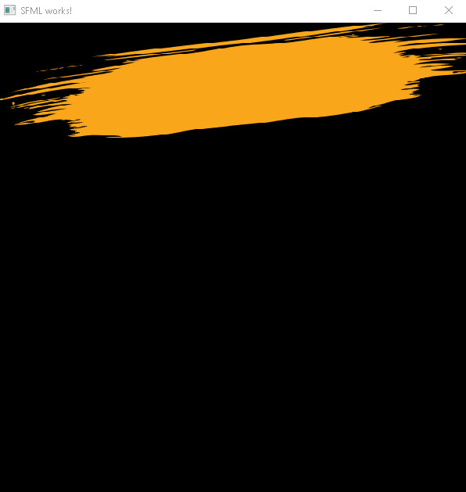

**Various Geometric Shapes**

#include "stdafx.h"

#include "SFML/Graphics.hpp"

#include <iostream>

#include <windows.h>

int main()

{

sf::RenderWindow window (sf::VideoMode(600, 600), "SFML works!");

sf::RectangleShape aShape(sf::Vector2f(300,300));

aShape.setSize(sf::Vector2f(150, 80));

sf::CircleShape aShape2(100); // radius

aShape2.setPosition(sf::Vector2f(100, 80));

aShape2.setPointCount(300); // gives more detail

sf::CircleShape aShape3(150, 6); // hexagon or 6 sided

aShape3.setPosition(sf::Vector2f(200,200));

while (window.isOpen()) {

sf::Event event;

while (window.pollEvent(event)) {

switch (event.type) {

case sf::Event::Closed:

window.close();

break;

}

}

window.clear();

window.draw(aShape);

window.draw(aShape2);

window.draw(aShape3);

window.display();

}

}

**Result**

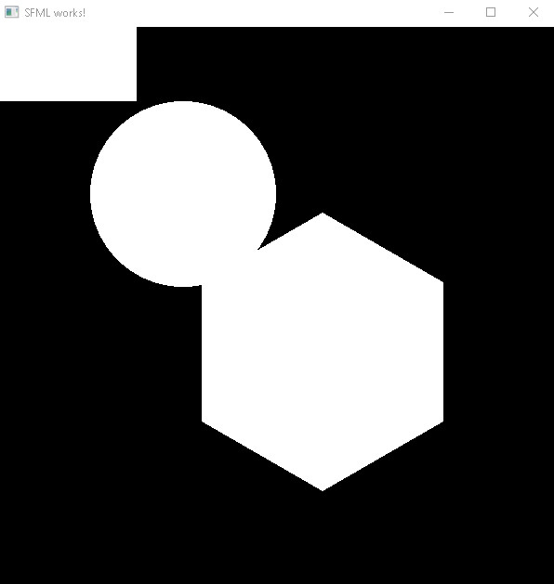

**Important notes:**